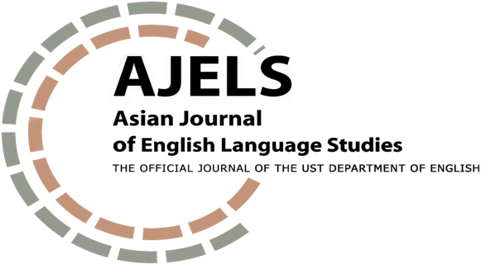

INITIAL REVIEW FORM
FOR BOOK REVIEW
SUBMISSION

Article Code: | Title:
Date Received:  Month Day Year | Date Read:  Month Day Year
Reviewer’s Name: | Decision:  [ ] For further review  [ ] For further review after minor revision  [ ] For further review after major revision  [ ] Not for further review

RUBRIC FOR RESEARCH ARTICLE REVIEW
Please highlight the descriptors that match your assessment of the submitted book review.

CRITERIA | COMPETENT (6) | SATISFACTORY (5) | DEVELOPING (4)
Summary | The summary succinctly provides a relevant description of the main topic and overall perspective and arguments of the book. | The summary discusses some of the key arguments of the book. | The summary is too long and overly detailed.
Critical Assessment | The review carefully highlights the significance and persuasive quality of the book’s arguments in light of current scholarship trends in linguistics. | The review provides some discussion of the significance and persuasive quality of the book’s arguments in light of current scholarship trends in linguistics. | The review does not the significance and persuasive quality of the book’s arguments in light of current scholarship trends in linguistics.
Final Commentary and Recommendations | The book review gives a clear recommendation as regards the reading worthiness of the book. The final commentary aligns with the summary and critical assessment provided. | The book review comments on the reading worthiness of the book. The final commentary is mostly aligned with the summary and critical assessment provided. | The book review does not provide a solid position on the reading worthiness of the book. Or the final commentary is somewhat inconsistent with points mentioned in the summary and critical assessment.
Clarity of Expression | The register and structure of the paper follow the conventions of academic English. Grammar, mechanics (including word count), and word choice are precise. | The register and structure of the paper is generally academic. Minor errors in grammar, mechanics, and word choice are noted. | The register and structure of the paper does not subscribe to academic English. Glaring errors in grammar, mechanics, and word choice distract the reader from logical comprehension of the intended meaning. Word count significantly exceeds the limit.
Sound Use of Literature | Relevant references, if any, are cited. Intext citations and reference entries match and adhere to APA 7th edition. | Relevant references, if any, are cited. However, some errors in the intext citations and reference entries are noted. | There is some evidence of plagiarism.
SCORE:
________/ 30

Decision Guide:
30 – 28: For further review
27 – 25: For further review after author implements suggested minor revisions
24 – 22: For further review after author implements suggested major revisions
21 and below: Not for further review

QUALITATIVE COMMENTS
Please give detailed feedback to support your evaluation of the article.

What are the strengths of this book review?

What are the critical areas that need to be improved at this stage?

What is the main reason why this book review is not recommended for further review?

