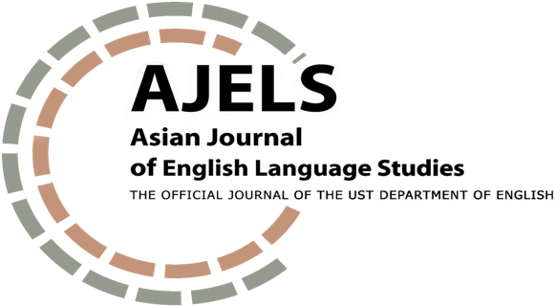

INITIAL REVIEW FORM
FOR RESEARCH ARTICLE
SUBMISSION

Article Code: | Title:
Date Received:  Month Day Year | Date Read:  Month Day Year
Reviewer’s Name: | Decision:  [ ] For further review  [ ] For further review after minor revision  [ ] For further review after major revision  [ ] Not for further review

RUBRIC FOR RESEARCH ARTICLE REVIEW
Please highlight the descriptors that match your assessment of the submitted article.

CRITERIA |  | COMPETENT (3) | SATISFACTORY (2) | DEVELOPING (1)
Content and cohesion
 | Abstract | The abstract succinctly presents the rationale of the study, the research objective, relevant framework and/or key literature, an overview of the findings, key conclusions, and potential implications. | The abstract discusses most of the key elements of the article but needs to improve the succinct presentation of the rationale of the study, the research objective, relevant framework and/or key literature, an overview of the findings, key conclusions, and potential implications. | The abstract is too long and does not effectively present the rationale of the study, the research objective, relevant framework and/or key literature, an overview of the findings, key conclusions, and potential implications.
 | Background of the Study | The background of the topic comprehensively discusses relevant issues and trends that support the significance of the proposed study. | The background of the topic discusses relevant issues and trends that support the significance of the proposed study. | The background of the topic does not discuss relevant issues and trends that support the significance of the proposed study.
 | Literature Review | The literature review effectively synthesizes what is known so far about the selected topic based on mostly current (dated at least 2010) research. It also clearly describes what is lacking in current knowledge and shows how the proposed project helps fill this gap. | The literature review somewhat synthesizes what is known so far about the selected topic. However, the reviewed studies are mostly dated (older than 2010) and discussion of current knowledge needs more detail. It somehow identifies a research gap that the proposed project helps fill. | The literature review does not synthesize what is known so far about the selected topic. It merely enumerates findings of related research with minimal discussion of the current state of knowledge that the study is building on. It does not clearly identify a research gap.
 | Research Questions | The question/s are effectively formulated and clearly demonstrate a potential contribution to an identified research gap. | The question/s are somewhat effectively formulated and demonstrate a potential contribution to an identified research gap. | The question/s are not effectively formulated and do not clearly demonstrate a potential contribution to an identified research gap.
 | Framework | The relevant framework for the study is clearly discussed, convincingly justifying how its use can address the research question/s. | The relevant framework for the study is mentioned but needs to be discussed more clearly in order to justifying how its use can address the research question/s. | The framework for the study is not clearly discussed.
 | Method | The method section clearly discusses well-reasoned decisions as regards the choice of research site, data, and analysis approach. | The method section sufficiently discusses the research site, data, and analysis approach. | The method section does not sufficiently discuss the research site, data, and analysis approach.
 | Results and Discussion | Data and discussion clearly and comprehensively answer the research questions. The data is logically and clearly presented. Comprehensive descriptive and critical analyses are provided for each data presentation. Arguments are clear and strongly supported by relevant literature. | Data and discussion answer the research questions. The data is logically and clearly presented. Descriptive and critical analyses are provided but need to be further elaborated and developed. Arguments are somewhat clear but could be expressed more precisely and supported by more relevant literature. | Data and discussion do not align with the research questions. Data presentation is not clear. Descriptive and critical analyses are limited. Arguments are not fully articulated and are not supported by any relevant literature.
 | Conclusion | The conclusion effectively summarizes the answers to the research questions, highlights the main arguments of the paper, and discusses important implications of the study, including recommendations for further research. | The conclusion mostly summarizes the answers to the research questions, mentions the main arguments of the paper, and discusses some implications of the study. | The conclusion does not clarify the answers to the research questions or the arguments of the paper. Implications are not discussed.

Clarity of Expression | The register and structure of the paper follow the conventions of academic English. Grammar, mechanics (including word count), and word choice are precise. | The register and structure of the paper is generally academic. Minor errors in grammar, mechanics, and word choice are noted. | The register and structure of the paper does not subscribe to academic English. Glaring errors in grammar, mechanics, and word choice distract the reader from logical comprehension of the intended meaning. Word count significantly exceeds the limit.
Sound Use of Literature | Relevant references are cited. Intext citations and reference entries match and adhere to APA 7th edition. | Relevant references are cited. However, some errors in the intext citations and reference entries are noted. | Minimal (less than 10) references are cited. APA conventions are not properly followed, and/or there is some evidence of plagiarism.
SCORE:
________/ 30

Decision Guide:
30 – 28: For further review
27 – 25: For further review after author implements suggested minor revisions
24 – 22: For further review after author implements suggested major revisions
21 and below: Not for further review

QUALITATIVE COMMENTS
Please give detailed feedback to support your evaluation of the article.

What are the strengths of this scholarly paper?

What are the critical areas that need to be improved at this stage?

What is the main reason why this paper is not recommended for further review?

